Problem after system crash

Error before cloning, immediately after diskless client system crash. Maybe the v-node from the image file is inconsistent .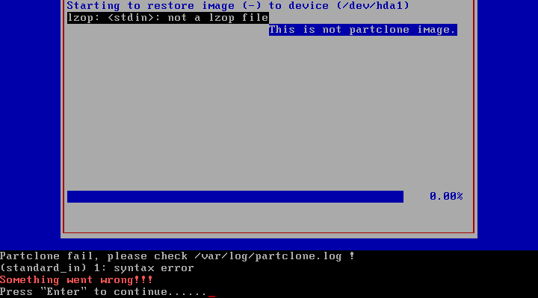
/var/log/partclone.log file, on clonezilla server (DRBL Server Live CD):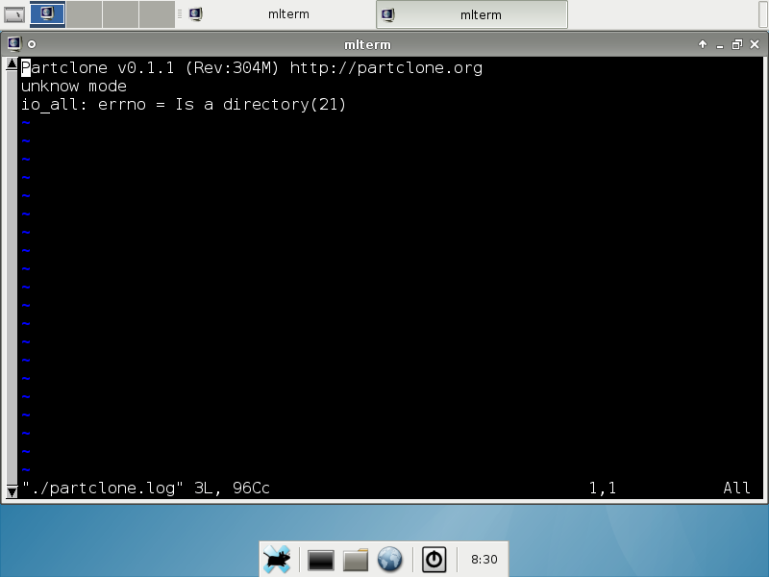
After aproximately one minute, without going down the service, it can restore the image with no problems.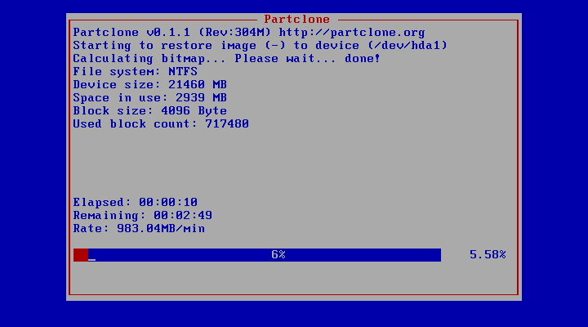
Do you know, why does this happens?
The unique hypothesis I have is that system crash results inconsistency on files readied from NFS Server.

